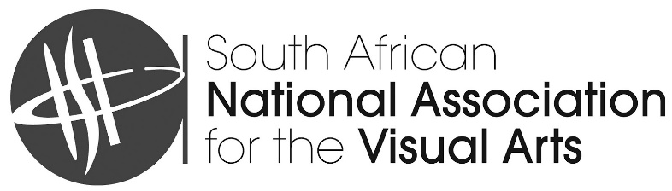
South African National Association for the Visual Arts (SANAVA)
Registration no 303-503-NPO | PBO 930 023 486
Member of the International Association of Art / Association Internationale des Arts Plastiques (IAA/AIAP) in official relations with UNESCO
Secretary: Ané du Plessis | info@sanava.co.za | (+27) 82 839 8834
1. APPLICATION FORM
Application form for an artistic residency at the Cité internationale des arts in Paris, France.
Full Name and Surname
______________________________________________________________________________________
I.D Number ____________________________________ Passport Number __________________________
Age ___________________________________________________________________________________
Residential Address ______________________________________________________________________
_______________________________________________________________________________________
Postal Code _____________________________________________________________________________
Cell Number____________________________________ Email ____________________________________
Of which SANAVA Branch are you a member? _________________________________________________
Academic and Professional Qualifications
- __________________________________________________________________________________

- __________________________________________________________________________________

- __________________________________________________________________________________

- __________________________________________________________________________________

Name/s & contact details of academic/ professional references (gallery, curator, etc.)
_______________________________________________________________________________________
_______________________________________________________________________________________
_______________________________________________________________________________________
_______________________________________________________________________________________
Preferred period during which you would like to carry out the artistic residency. (Two months minimum and three months maximum). Your preference cannot be guaranteed due to the number of applications received.
From ___________________________________________ to _____________________________________
Name and address of next of kin in South Africa _________________________________________________
________________________________________________________________________________________
________________________________________________________________________________________
Cell number for above-mentioned next of kin in South Africa __________________________________
________________________________________________________________________________________
DATE _________________________________ SIGNATURE ______________________________________

2. CONTRACT AGREEMENT
Contract of Agreement entered into and concluded between:
- The South African National Association for the Visual Arts, and
- The Beneficiary:
2.1 As the Beneficiary, I agree:
a) To return to South Africa after my sojourn overseas. The artistic residency can take place for a period of two months minimum to three months maximum. This period is intended for work and research in Paris, and not either as a stepping-stone to leave South Africa or a place from which to visit the rest of Europe.
b) To on my return to South Africa from the Cité internationale des arts, submit a written report to SANAVA
regarding my experience and activities while at the Cité. This is to be accompanied by visual material for possible publication within TWO months of your return.
c) To advance the interests of SANAVA in general by acknowledging it in all publicity, e.g. television, radio, the press and digital media.
d) That in order to assist SANAVA in building up a collection of works of art by artists who have enjoyed the privilege of visiting the Cité internationale des arts, I undertake to donate a work of art to SANAVA, prior to my departure, which would be housed at the Head Office of SANAVA or at an appropriate venue. Please bear in mind that work on paper, canvas or board should be framed and that the artist is responsible for the delivery cost to Pretoria.
e) To accept that the selection of the work will be done by a Selection Committee appointed by SANAVA. For the purpose of selection, I will be required to submit pictures and details of my five most recent works (as included in my artist file).
f) To donate R2000 towards the SANAVA studios’ refurbishment fund. This is to ensure the good funds for future renovations and studio upkeep.
g) That an artist donating an artwork will be invoiced R2000 before leaving for Paris, and other individuals closely associated with the visual art, but not able to donate an artwork (for example a writer), will be invoiced R4500 before leaving for Paris. These amounts must be paid to SANAVA before leaving for the Cité residency.

  - As the Applicant (Beneficiary), I understand that:

- once my application and residency dates have been finalised and I have been informed thereof and
I agreed, no alteration of dates would be possible,
- if, for any reason whatsoever, I am unable to take up residence at the Cité for the period allocated to me,
I shall be required to advise the secretariat of SANAVA accordingly, at least four months prior to the date
of commencement of my stay and, furthermore,
- if I fail to do so, I shall be required to pay to the Cité the deposit which SANAVA has prepaid and whatever
additional costs regarding administration and levy that may be required and I undertake to reimburse
SANAVA for any such amounts as it may be required to pay the Cité in consequence of my not taking
up residence at the Cité,
- the principle of an artists’ residence, which is distinct from a travellers’ hotel, supposes that the resident
be alone. The accommodation of an accompanying companion, if announced according to regulations,
is possible. The only exception made for a third person will be, in specific cases, that of a young, not
school going, child under 11 years old. It is necessary to inform the administrators at the Cité internationale des arts in advance regarding the number of people who will occupy the live-in studio.

Signed at __________________________________________on _____________________20____________

______________________________ ___________________________________________
Signature of Applicant (Beneficiary) Name in full

- WITNESS: (1)

______________________________ ____________________________________
Signature of Witness Name in full

- WITNESS (2)

______________________________ ____________________________________
Signature of Witness Name in full

3. LETTER OF INDEMNITY
I, _____________________________________________________________ hereby indemnify SANAVA
against any loss, arising from an act of omission on my part related to my stay at the Cité internationale des arts in Paris, France.

Signed at ___________________________________ on this ____________day of _______________ 20 __

______________________________ ___________________________________________
Signature of Applicant (Beneficiary) Name in full
- WITNESS: (1)

______________________________ ____________________________________
Signature of Witness Name in full
- WITNESS (2)

______________________________ ____________________________________
Signature of Witness Name in full

